APPLICATION FORM
PERSONAL DATA

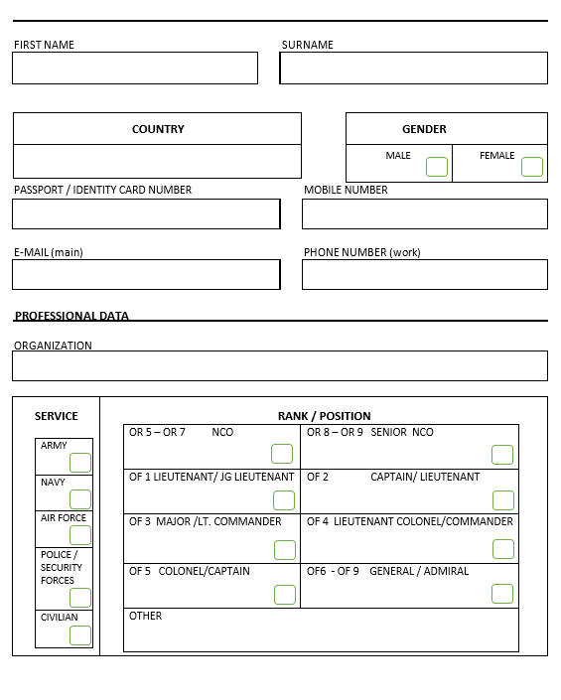

PROFESSIONAL DATA (continued)

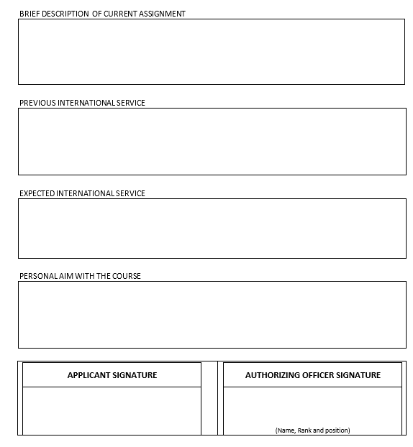

Please send the application to the Course Secretariat
E-Mail: omi.int@mde.es

