**Invitation to apply for the BSDI Course**

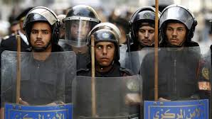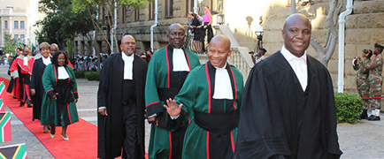

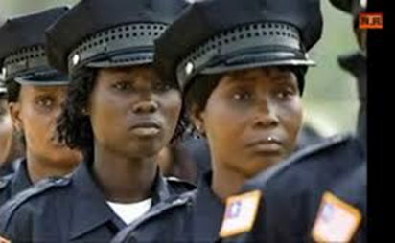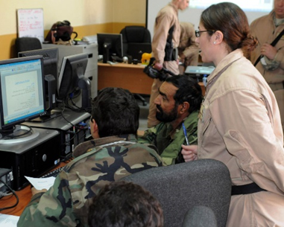

**Gender and Security Sector Reform**

***An international course for middle management***

***civilian and military professionals***

2 – 4 November 2016

Military Residence Don Quijote

Madrid, SPAIN



**Background**

Due to complexity of current operations, there is an increasing awareness of the need for both military and civilian personnel to be equipped with practical means to develop the SSR (Security Sector Reform) concept as well as its implementation on the ground. Conflict and post-conflict transition processes, including SSR, affect women, girls, men and boys differently. Consequently, their perspectives on conflict resolution, peace-building and post conflict programs and policies also vary. We need to listen and respond to both perspectives when developing gender-responsive SSR. Not just because it is the right thing to do, but because it makes our operations more effective and sustainable. Actively engaging women and men on equal grounds, within our own missions and institutions as well as in rebuilding post-conflict societies, is a matter of operational effectiveness. This implies changes in the way we plan and implement our SSR programs, which is precisely what “*Gender and Security Sector Reform*” envisions to accomplish.

|  |
| --- |
| In 2016, the course will be held on the following dates:  **2 – 4 November**  **Military Residence “Don Quijote”, Madrid, SPAIN** |

This innovative international course, a result of collaboration between the Spanish and Dutch Ministries of Foreign Affairs and Defence, responds to these demands by providing participants with applicable knowledge and skills needed to face these new challenges.

The three days course is based on the understanding of the different needs, priorities and capacities of women, girls, men and boys that SSR must respond to, building on synergies between defence, diplomacy and development with regards to gender and human rights aspects.

**Aim**

Providing participants a better understanding of SSR processes and practices from a gender perspective and the role of the different actors.

**Learning Objectives**

*By the end of the course the participant should be able to****:***

* Understand the main concepts of SSR
* Understand the comprehensive approach
* Explain the main concepts of gender
* Explain the importance of gender in SSR processes
* Understand how to integrate gender in SSR processes
* Identify the challenges in SSR programming
* Identify the various gender aspects/challenges in SSR programming
* Understand the role of different actors in SSR processes

**Target Audience**

The course is primarily aimed at **middle management** military officials, civilians including police, and diplomats from EU Member States and EU Institutions and relevant Agencies, who are assigned or interested to participate in (future) CSDP, NATO or UN missions or operations, or who are to be assigned to a position in a fragile state. Students from interested third countries or multilateral organizations may also participate in the course.

*No security clearance is required, as all materials used in the lectures will be unclassified.*

**Training & Language**

* The working language is English, no translation will be provided. Participants should meet the Common European Framework of Reference for Languages (CEFR) Level B2 or NATO STANAG 6001 3-3-3-3.
* All lectures will be performed indoors, both plenary lectures as syndicate sessions
* Students will receive a certificate upon completion of the course.

**Duration**

The total course duration is of 3 days.

**Methodology**

Topics are examined through lectures, plenary discussions, exercise and working groups. Each participant will be encouraged to take an active role and sharing of experiences and exchange of expertise among the participants will be encouraged throughout the course.

Reading materials for individual study are provided in advance of the course in order to ensure a common basic level of knowledge on SSR and Gender. Syndicates and group discussions shall be used to deepen the understanding of certain areas.

**Course Contents**

|  |  |
| --- | --- |
|  | **Theme 1: Concepts and Context** |
|  | * Key gender and SSR concepts * Comprehensive Approach in international missions * Gender and Security Sector Reform  |  | | --- | | **Theme 2: Gender in SSR programs** | | * When to incorporate gender in SSR programming | | * How to incorporate gender in SSR programming | |
|  |  |
|  | **Theme 3: Gender responsive SSR in operations** |
|  |  |
|  | * Diverse perspectives on SSR in missions. * Incorporating a gender perspective in the security sector |
|  |  |
|  |  |
|  |  |

**Application & Selection**

Application forms should be sent no later than 7 Oct 2016. Prospective participants should seek approval through the regular authorizing mechanisms relevant to the respective ministries or organizations. The application form is to be signed both by the participant and the authorizing officer.

*No course fee is charged*.

Applications meeting the following profile will be considered for admittance:

Military: Captain up to colonel

Civilian: Officials from Ministries of Foreign Affairs, Defence, Interior Affairs, EU institutes and multilateral organizations who are to be assigned to operations, to fragile states or relevant embassies/permanent missions/departments, or to participate in short missions/expert pools.

*Nominations received after the deadline will only be considered if space is available.*

All applications will receive a confirmation of receipt. Letters of admission will be sent prior to the course.

**Accommodation, Meals & Travel**

Single room accommodation arrangements are made in the Military Residence “Don Quijote” in Madrid, Spain.

Accommodation costs and meals will be covered by the participants or sending organization. These costs are as follows:

- 15.42 Euros **per night** for accommodation

- 50 Euros for breakfast, lunch and coffee breaks during the **whole course**.

Detailed logistical and administrative details will be provided upon confirmation of the admittance to the course.

Travel expenses to and from Madrid are to be covered by the sending unit/country. Please inquire timely about possible visa requirements for Spain. It is the sending country’s responsibility to arrange visa for the participant(s).

**Dress code**

Military and police:

Opening session and closing ceremony: Service day uniform (jacket and tie);

All other sessions: Day uniform/working dress (not battle dress)

Civilian:

Opening session and closing ceremony: business atire

All other sessions: business casual

**Contact & Application**

Completed application forms should be sent to [omigualdad@oc.mde.es](mailto:omigualdad@oc.mde.es)

|  |
| --- |
|  |
|  |
|  |
|  |

*Points of Contacts:*

For logistic and administrative matters

[omigualdad@oc.mde.es](mailto:omigualdad@oc.mde.es)

or

Course Coordinator

Lt Cdr Teresa Balanzat

[mbalmei@fn.mde.es](mailto:mbalmei@fn.mde.es)

Phone: +34 91 213 2909

*For more information, including all necessary forms, please visit the course website:*

[*http://www.defensa.gob.es/ministerio/organigrama/subdef/digenper/omi/*](http://www.defensa.gob.es/ministerio/organigrama/subdef/digenper/omi/) *(open Áreas de trabajo)*